Annexure-IV
The Daily Star, January 23, 2012 Page No.-10 & 11
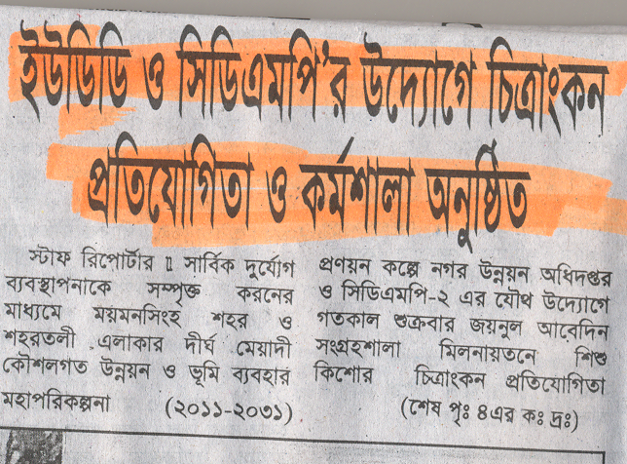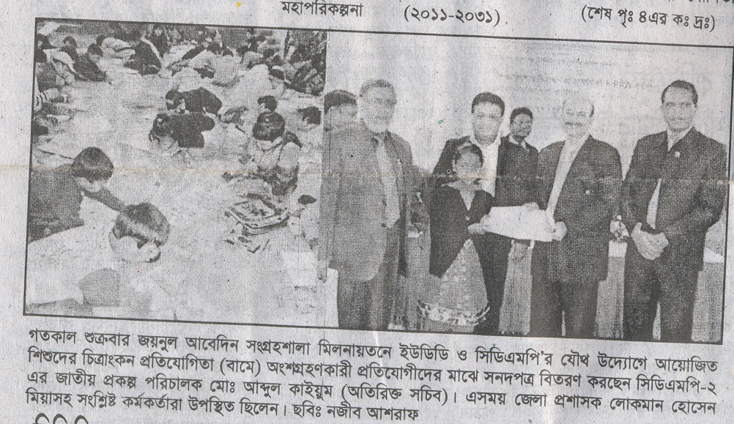
‰`wbK Rvnvb, gqgbwmsn, 21 Rvbyqvix-2012 cÖ_g cvZv I 4_© cvZv
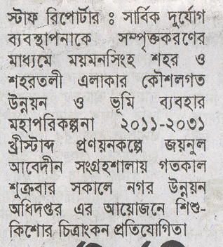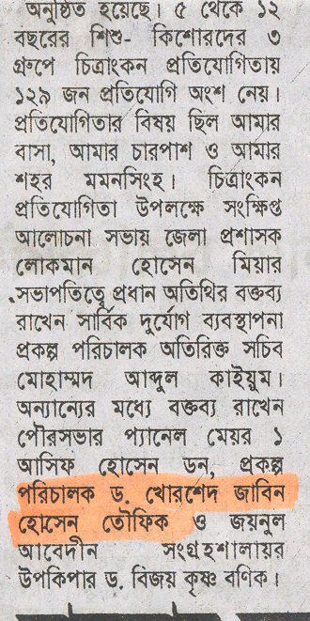
‰`wbK meyR, gqgbwmsn, 21 Rvbyqvix-2012 cÖ_g cvZv

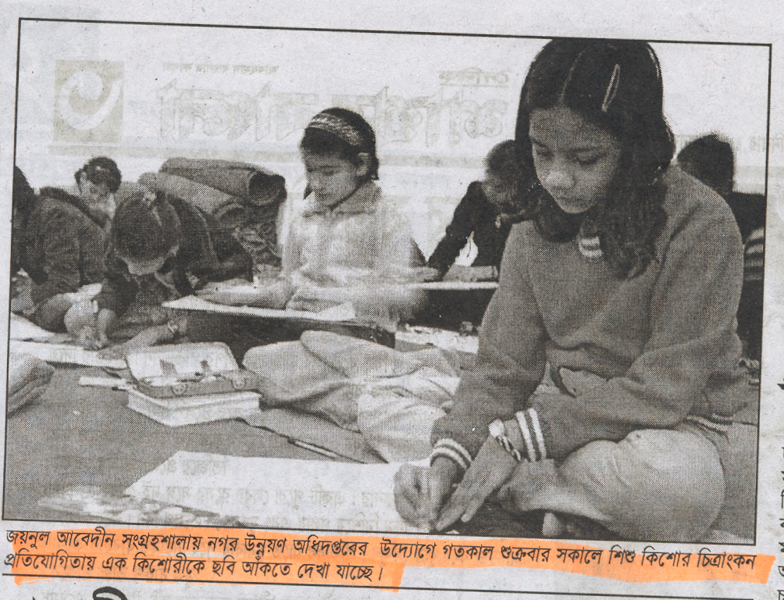
‰`wbK kvk¦Z evsjv, gqgbwmsn, 21 Rvbyqvix-2012 , ‡kl cvZv
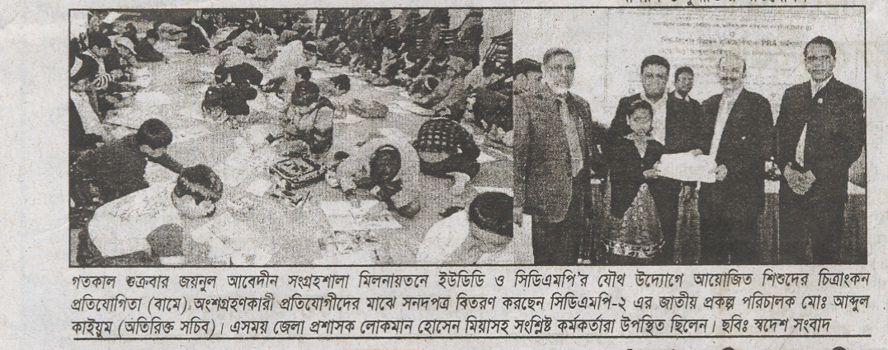
‰`wbK ¯^‡`k msev`, gqgbwmsn, 21 Rvbyqvix-2012 , cÖ_g cvZv
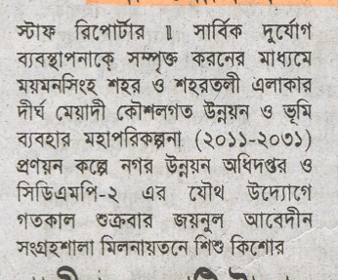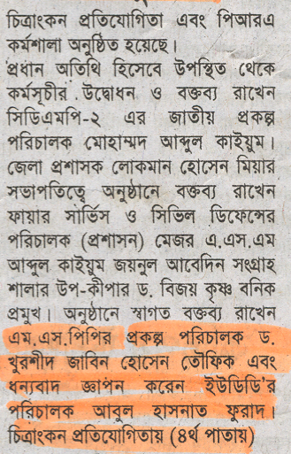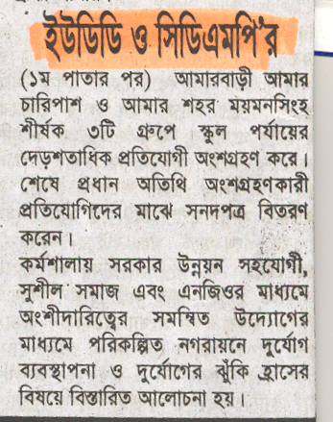
‰`wbK ¯^‡`k msev`, gqgbwmsn, 21 Rvbyqvix-2012
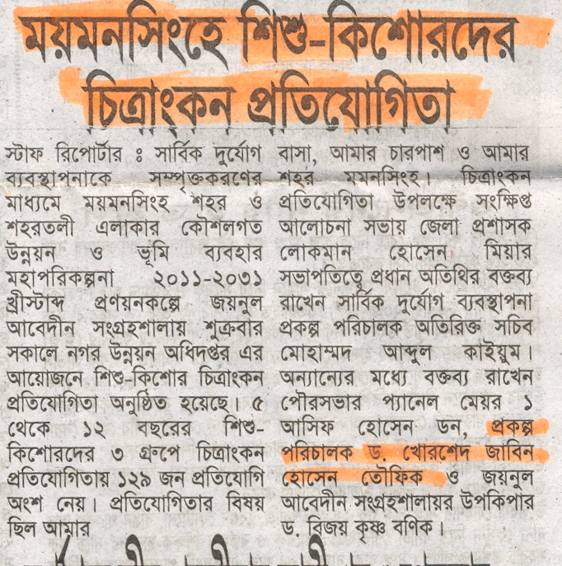
‰`wbK ¯^Rb, gqgbwmsn, 21 Rvbyqvix-2012 , cÖ_g cvZv

